ASSIGNMENT 1

# BARCHART

MARKETING SPEND BY STATE

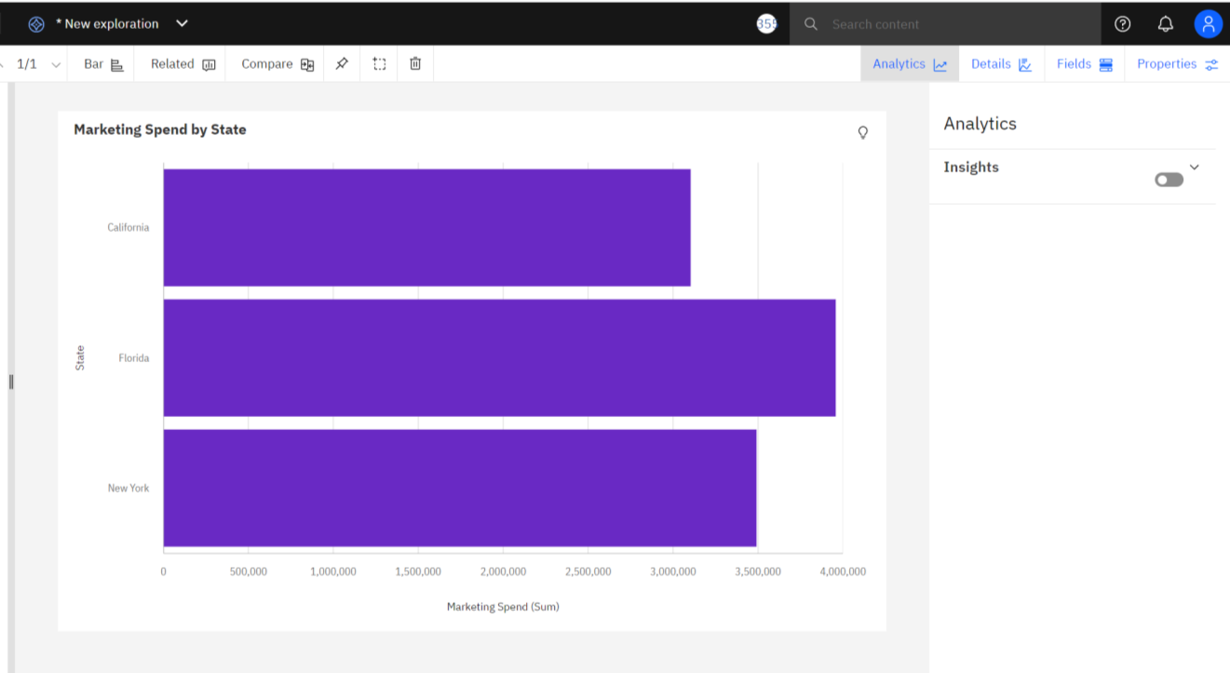

# PIE CHART

R&D SPEND BY STATE

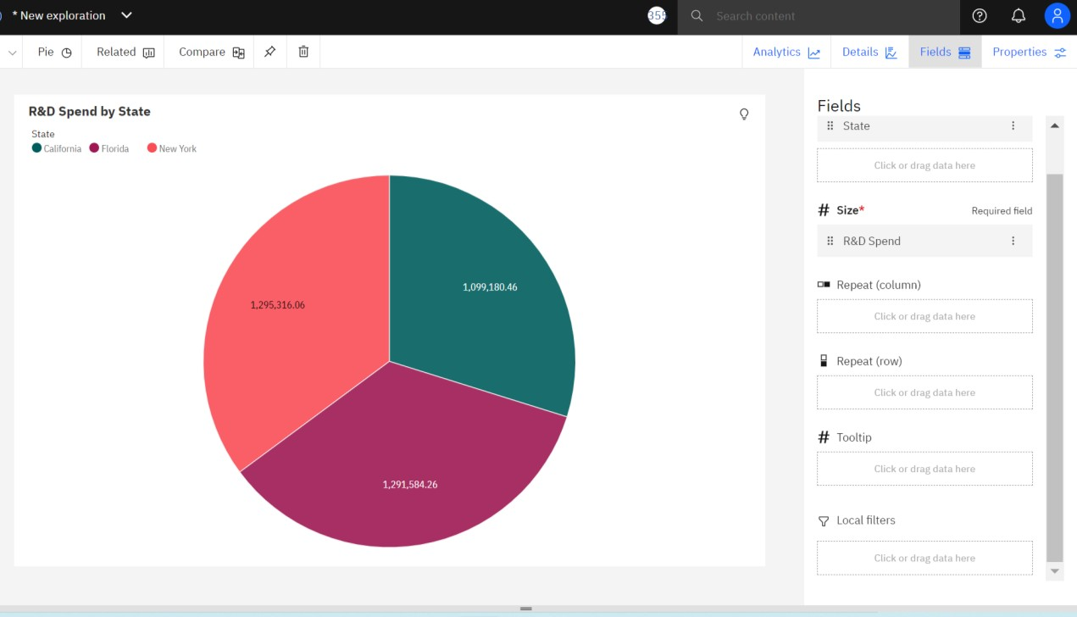

# LINE AND COLUMN CHART

MARKETING SPEND AND PROFIT BY STATE

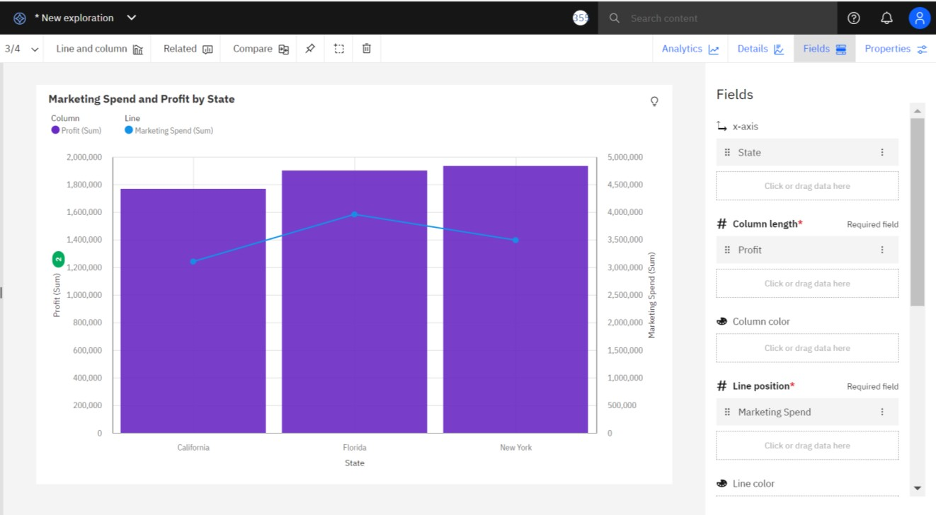

# POINT PLOT

Marketing spend by state

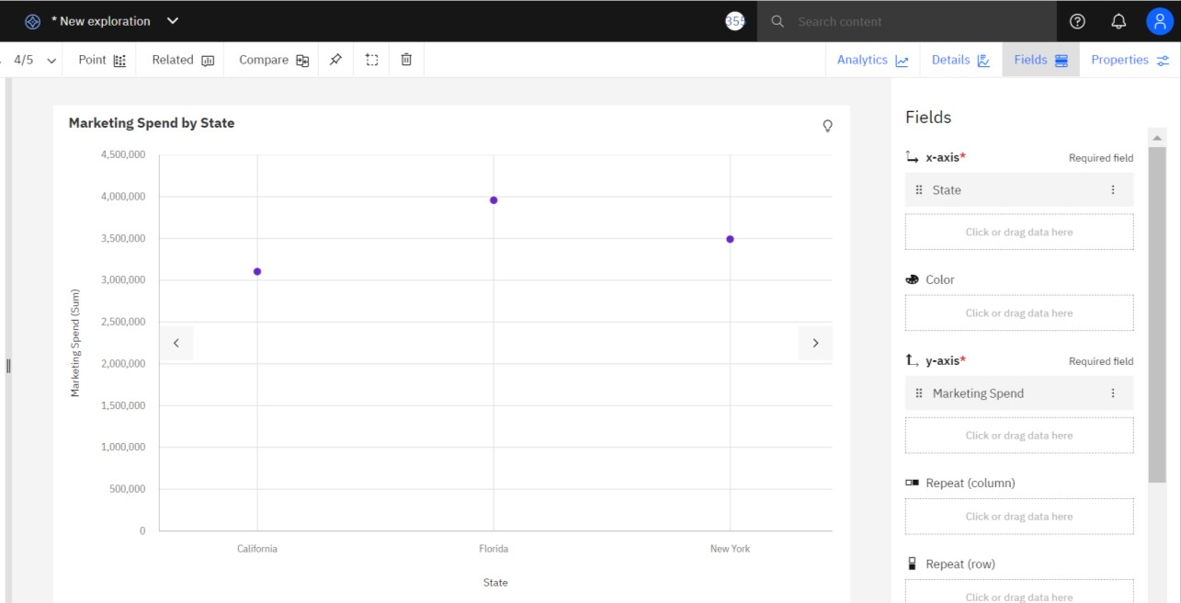

# AREA PLOT

Profit by Administration

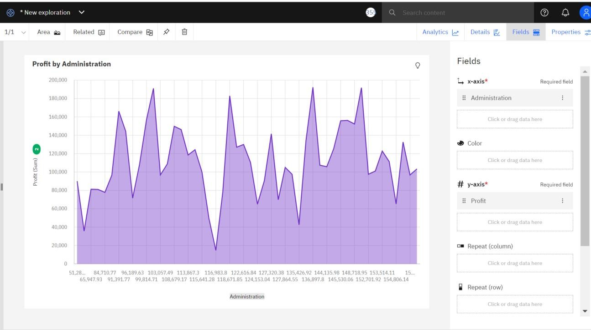

# HEAT MAP

Marketing Spend By R&D Spend and State

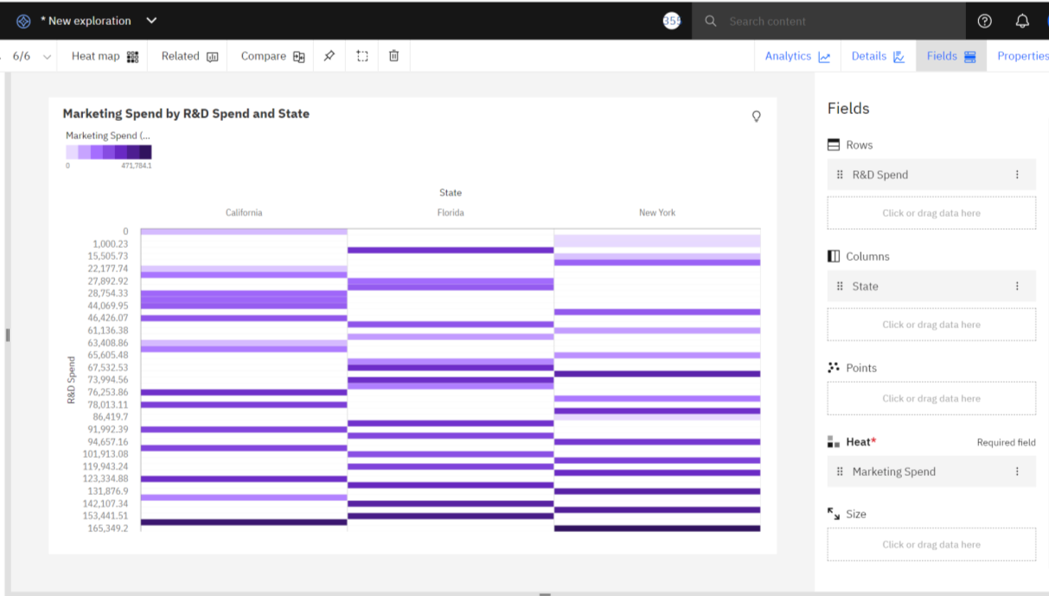

**PACKED BUBBLE CHART**

